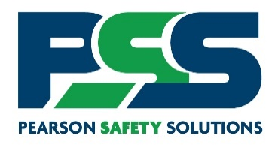
Effective: 00/00/0000
Contractor Prequalification Requirements via LinkQualify
Pearson Safety Solutions, LLC (PSS) will be administering the [HIRING CLIENT] contractor prequalification program. Before entering [HIRING CLIENT], you will be required to upload your certificate of insurance(s), complete contractor agreement documents, and provide other required information in PSS’s LinkQualify online portal. This service is free to use as a contractor.
You should receive an email from system@app.pearsonsafety.com on 00/00/0000 to begin the process. It is recommended to have the PSS email/domain whitelisted by IT to avoid delivery delays and to ensure it is not blocked by your email system.
After the effective date of this letter, all contractors must be approved by PSS before entering the facility. PSS will do its best to make this process as easy as possible by getting your company approved to perform the work. Please refer to the instruction document sent with this letter to start your prequalification process! Instructions will also be a Sample Document on your request when logged into PSS’s LinkQualify.
We are excited to begin working with you to ensure a safe workplace!
If you have questions about registration or technical issues, please contact:
PSS Support
Support@PearsonSafety.com (preferred)
866-982-SAFE (7233) x extension 1

